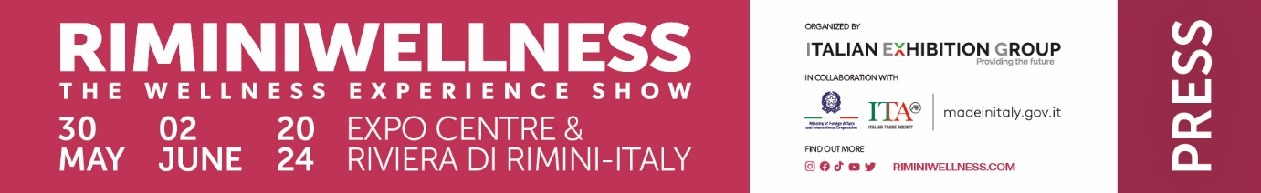

Final press release
(English translation)

RIMINIWELLNESS 2024 RACKS UP OVER 100 THOUSAND ACCESSES,
A PREDICTED SUCCESS FOR BUSINESS AND WELLBEING

- International professional sector on the rise: delegations from 25 countries
- Innovation and experiences throughout 28 pavilions with 300 exhibiting brands, 80 professional conferences, 500 appointments on the matching platform and 2,000 hours of training
- A major victory for RiminiWellness OFF in collaboration with the Municipality of Rimini: 240 events around the local area

Rimini, 2 June 2024 - Business, innovation and entertainment, international flair, quality of life and experiences: the numbers of the 18th edition of RiminiWellness have crowned it the catalyst for the entire industry and all the reference communities.
For the first time since the implementation in Italy of the new international calculation criteria, the Italian Exhibition Group (IEG) event dedicated to fitness, well-being, sport and healthy eating - which came to a close today at the expo centre in Rimini and in locations along the Riviera - clocked up over 100 thousand accesses, doubling also the number of foreign visits. Not to mention the international professional nature of the event also on the rise: 500 appointments on the matching platform and delegations from 25 countries.

With a renewed format and thanks to its double soul, both professional and consumer, RiminiWellness took over the entire expo centre from 30 May to today. The effectiveness of the strategy to strengthen the B2B area was reflected in the boost of numbers in this year’s edition confirming the direction taken towards new high-interest categories and B2B potential (Health, Riabilitech, Corporate Wellbeing, Hospitality and Real Estate).
RiminiWellness 24 occupied 170 thousand square metres both indoors and outdoors, filling 28 pavilions, and with 300 exhibiting brands divided into thematic areas: from Active, to FoodWell, to Holistic, to the new entry, Active Beauty. More than 2,000 hours of training and 80 events and conferences.
The entire Rimini area was infected by this wellness "fever", thanks to the 240 events of the RiminiWellness Off, the off-show event organized by IEG and the Municipality of Rimini.
RiminiWellness has re-established trust among operators and provided an authoritative sum-up of the industry with the General States of Fitness and Wellness, a non-stop series of training events in collaboration with REX Round-tables, The European House of Ambrosetti, University of Bologna Department of Quality of Life QUVI, University of Padua, CLUST-ER Salute Emilia Romagna, Tecnopolo di Rimini, ANIF, CIWAS, Institute for Sports Credit, Sport and Health, Confartigianato, Sardinia Region, Network of Healthy Cities and many others, reconfirming the success of HYROX and the extraordinary expansion of the Foodwell area, endorsing a balanced and taste-centred diet.

EXTRAORDINARY MEDIA VISIBILITY AND LARGE NUMBERS ON SOCIAL MEDIA
Hundreds of TV and radio reports and live broadcasts, articles in the trade press, online and offline reports and interviews, prestigious media partnerships, explosive numbers on social media have made RiminiWellness 2024 the emblem of a very promising summer season, thanks also to a variety of events scheduled in the local area.

MASSIVE INTERNATIONAL FLAIR WITH THE IEG WELLNESS NETWORK
RiminiWellness is undeniably the leading event of the IEG Wellness Network, IEG's global platform involving all industry insiders (operators, instructors, gym chains, sports centres, equipment manufacturers and distributors) as well as sports, fitness and wellness enthusiasts with trade fair events in Asia, Europe and North America.

Upcoming events:
• Dubai Muscle Show and Dubai Active (25-27 October 2024, Dubai)
• Brasil Trading Fitness Fair (22-24 November 2024, São Paulo, Brazil)
• Riyadh Muscle (21-22 February 2025, Riyadh, Saudi Arabia).

RiminiWellness will be returning to Rimini Expo Centre and the Riviera in 2025 for its 19th edition, in the month of May.

ABOUT RIMINIWELLNESS 2024
Date: 30 May - 2 June 2024; type: international show; organizer: Italian Exhibition Group S.p.A.; recurrence: annual; edition: 18th; open to: general public and operators; info: www.riminiwellness.com

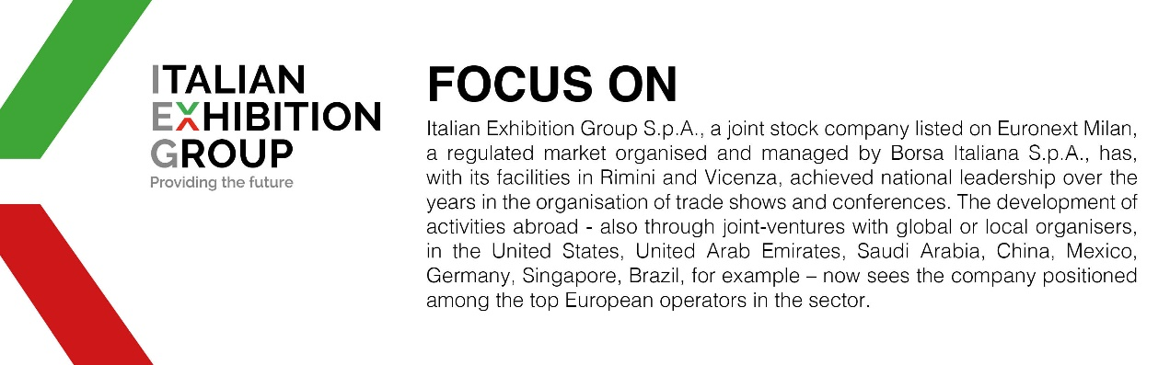

PRESS CONTACT ITALIAN EXHIBITION GROUP
head of corporate communication & media relation: Elisabetta Vitali |
press office manager: Marco Forcellini, Pier Francesco Bellini | press office specialist: Luca Paganin | international press office coordinator: Silvia Giorgi | media@iegexpo.it

MEDIA AGENCY RIMINIWELLNESS
Naper Multimedia| Zoe Perna | T. +39 02 97699600 | staff@napermultimedia.it

This press release contains forecast elements and estimates that reflect the management’s current opinions (“forward-looking statements”), particularly regarding future management performance, realization of investments, cash flow trends and the evolution of the financial structure. For their very nature, forward-looking statements have a component of risk and uncertainty, as they depend on the occurrence of future events. The effective results may differ (even significantly) from those announced, due to numerous factors, including, only by way of example: food service market and tourist flow trends in Italy, gold and jewellery market trends, green economy market trends; the evolution of raw material prices; general macroeconomic conditions; geopolitical factors and evolutions in the legislative framework. Moreover, the information contained in this release does not claim to be complete, and has not been verified by independent third parties. Forecasts, estimates and objectives contained herein are based on the information available to the Company as at the date of this release.

